**Prepared by- Shubham Mishra  
Email – mshraea@amazon.com**

**Task 1**

**Project Title: Library Management System (using SQL)  
  
Database Creation:**

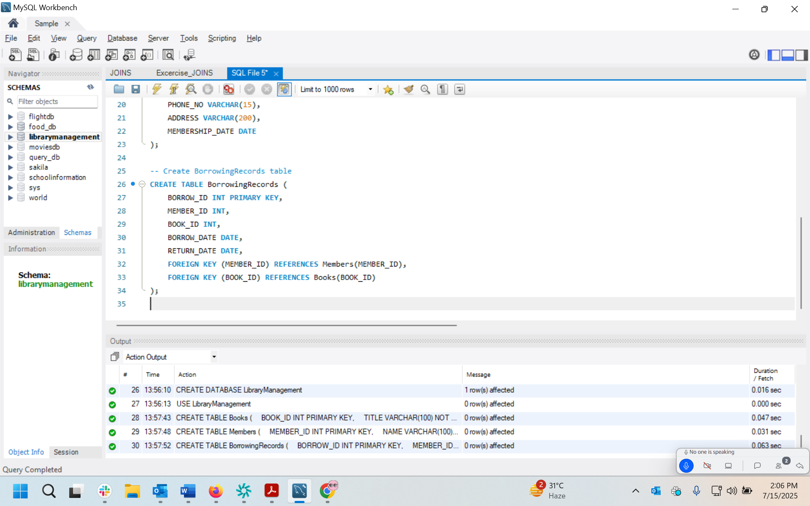

**Data Creation:**

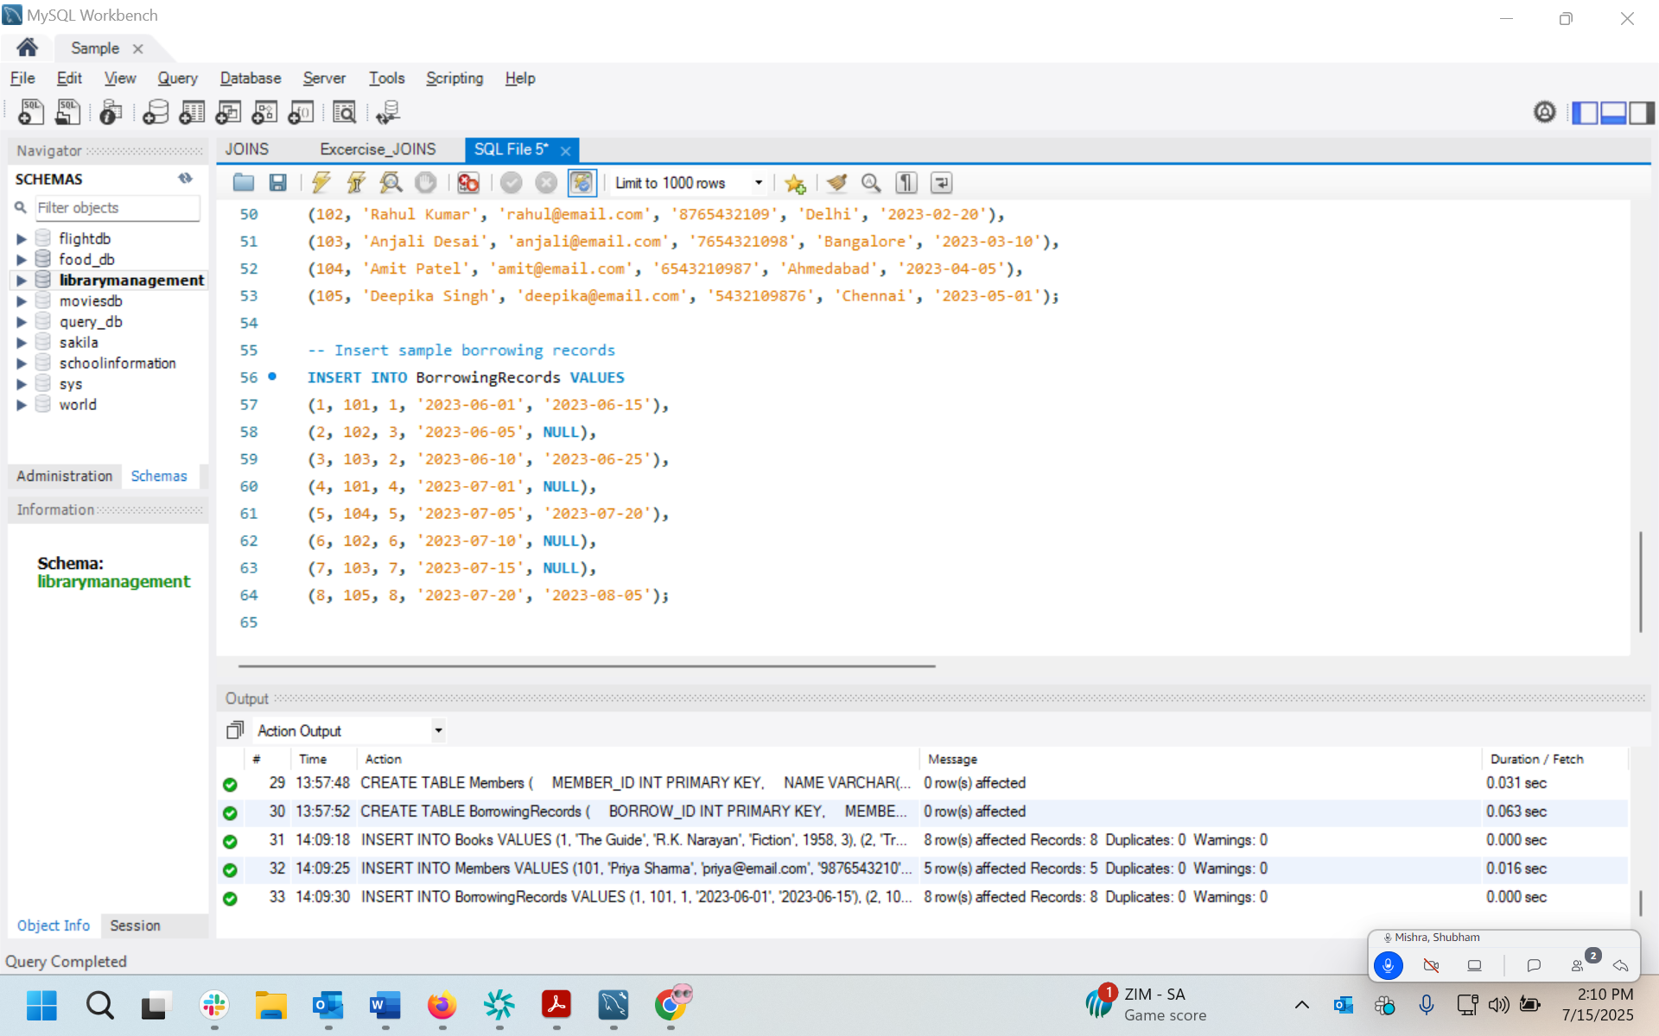

**Information Retrieval:**

a) Retrieve a list of books currently borrowed by a specific member.

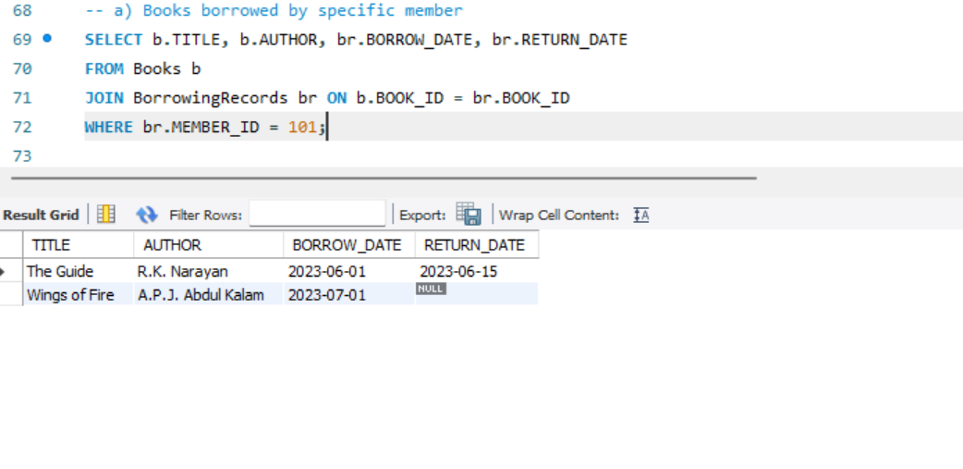

b) Find members who have overdue books (borrowed more than 30 days ago, not

returned)

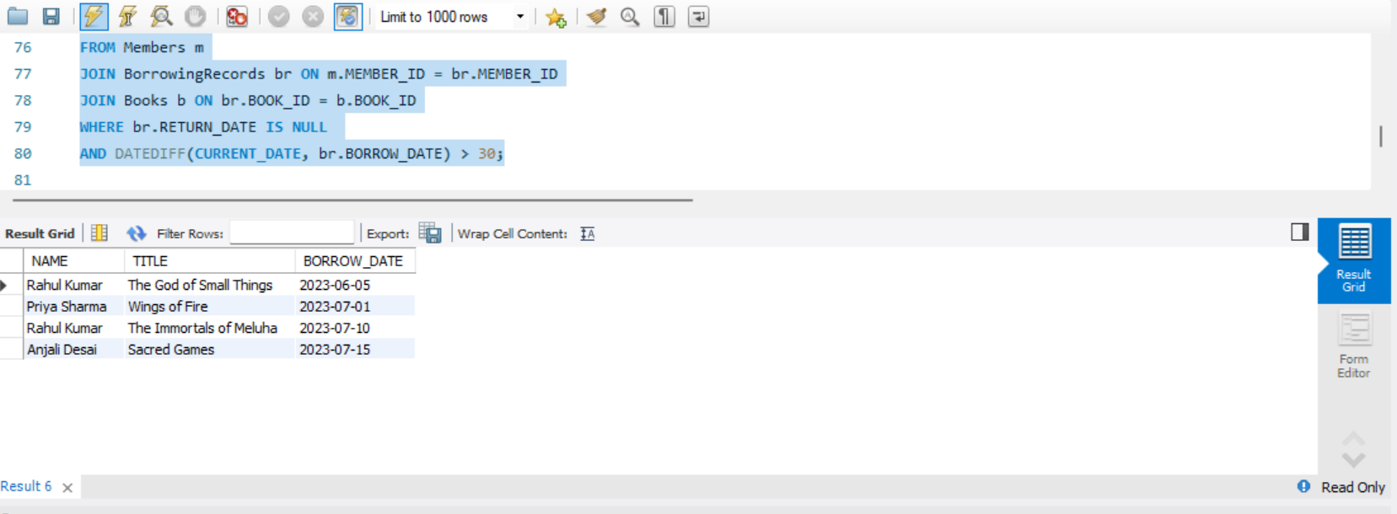

c) Retrieve books by genre along with the count of available copies.  
  
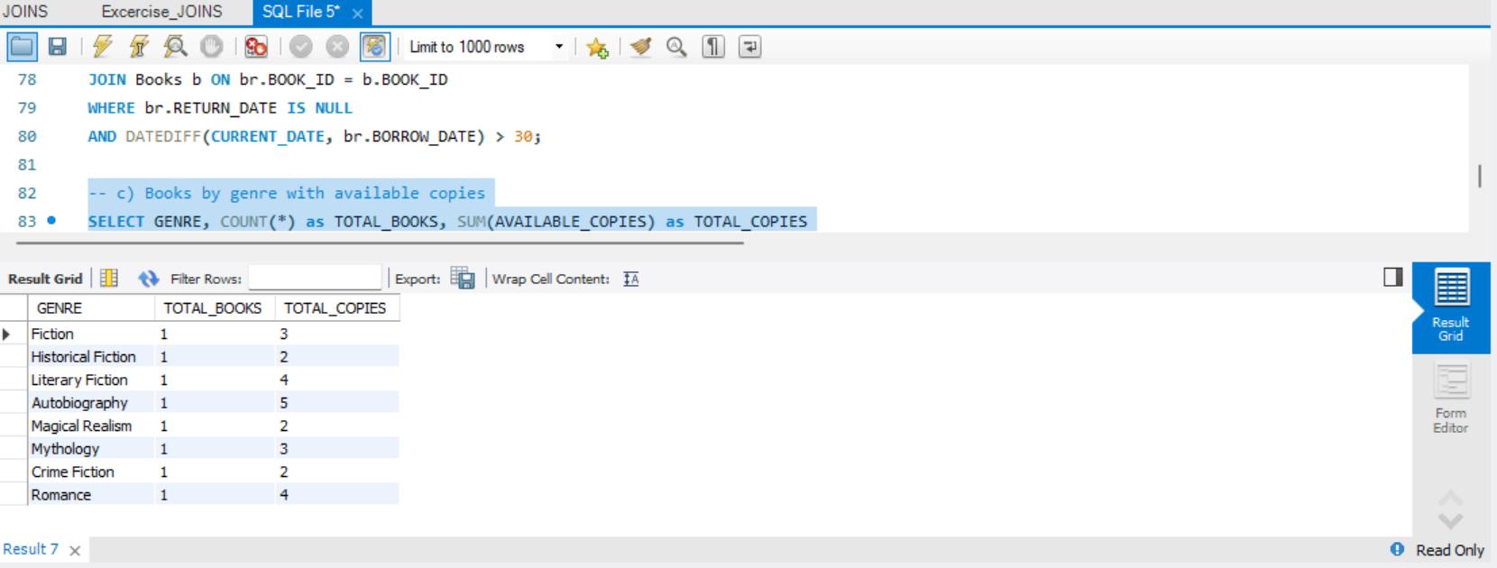

d) Find the most borrowed book(s) overall.

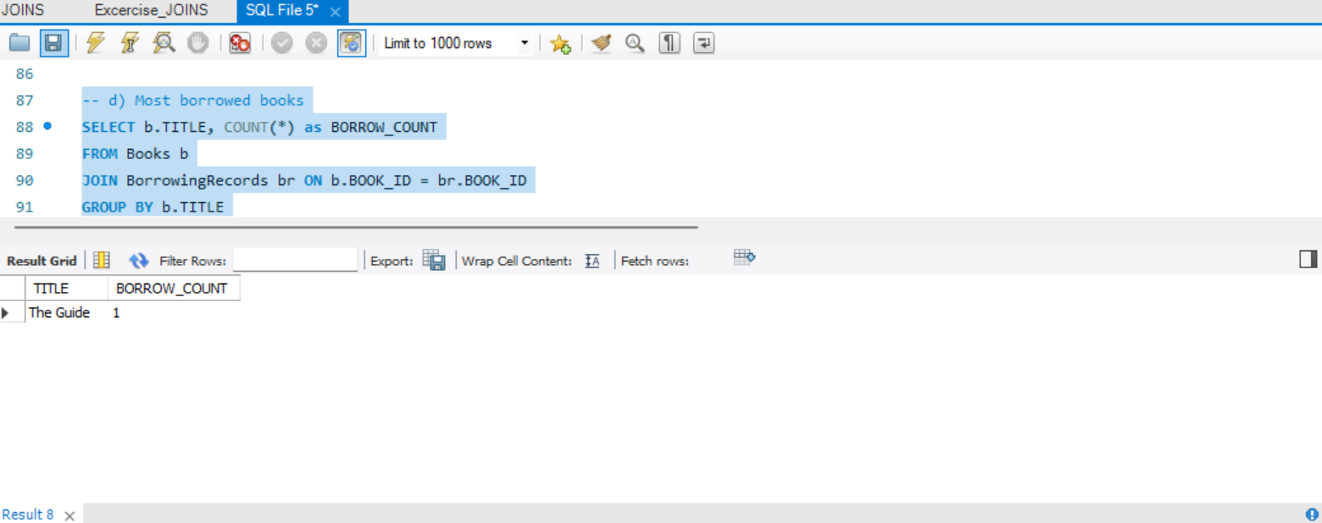

e) Retrieve members who have borrowed books from at least three different genres.

There are no members who have borrowed at least 3+ genres

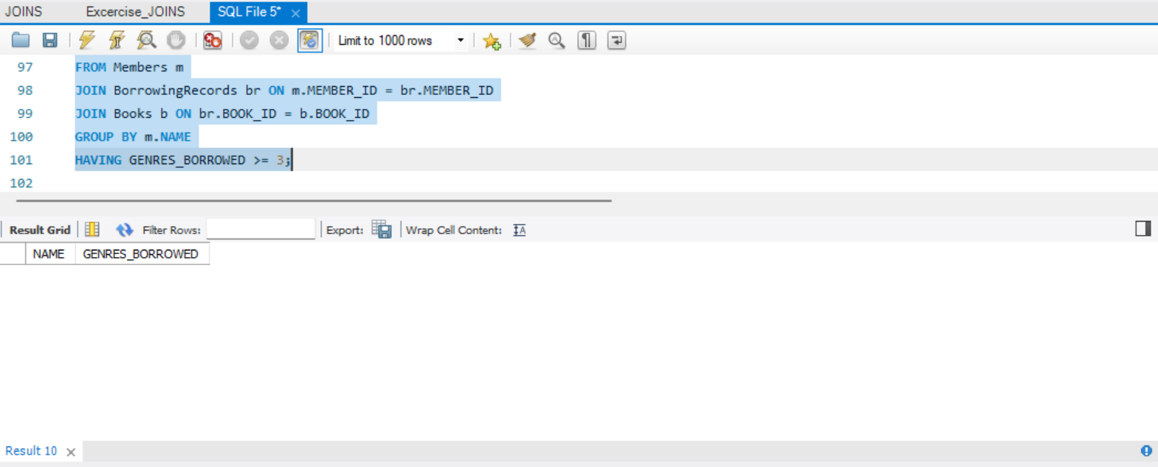

Reporting and Analytics:

a) Calculate the total books borrowed per month:

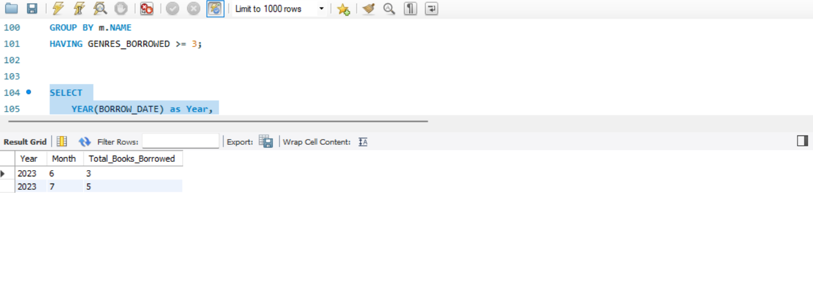

b) Top three most active members:

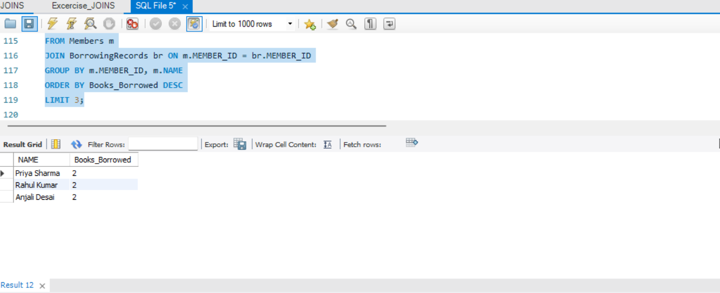

c) Authors whose books were borrowed at least 10 times: No Records

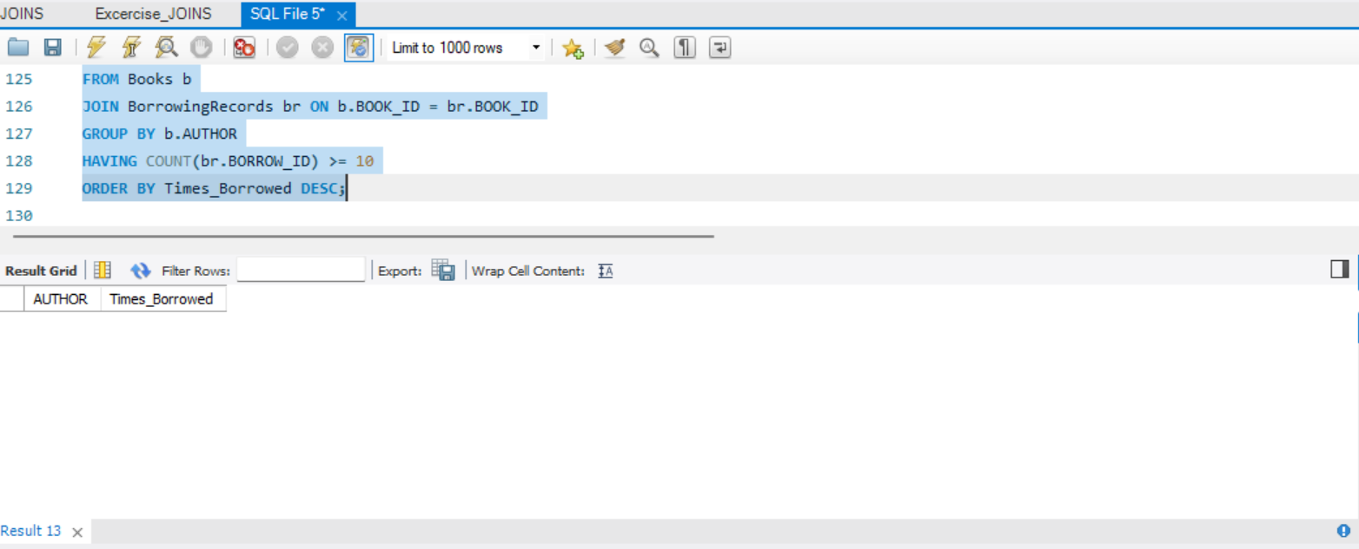

d) Members who have never borrowed a book:

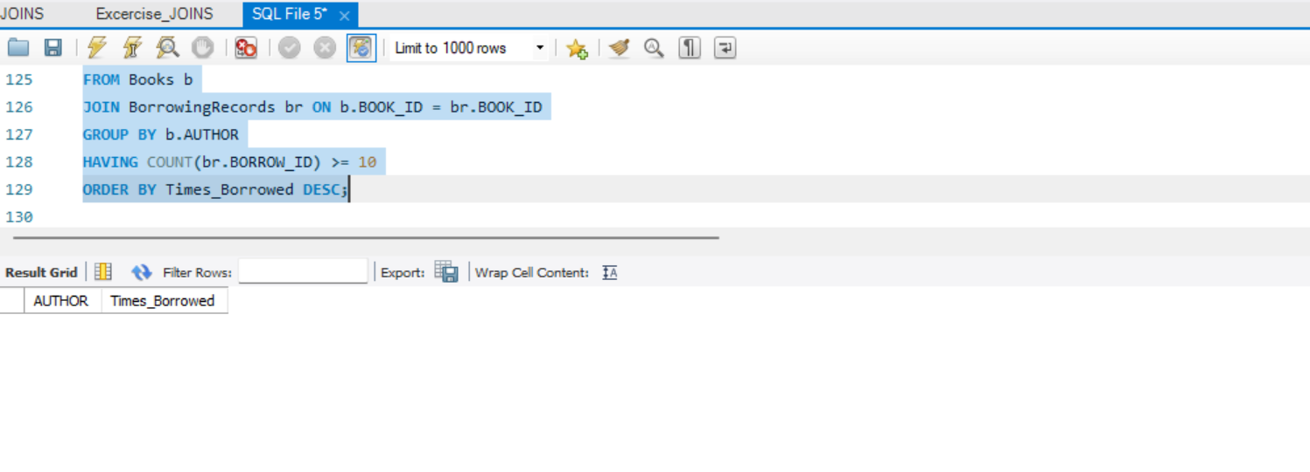

**TASK 2**

**Database Setup:**

**Create a database named payroll_database.**